EXERCISE 10
1. ﻿﻿﻿Display the sum of ages of employees working at Bignet.
SELECT SUM(age)
FROM employee_data;
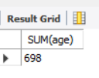
2. ﻿﻿﻿How would you calculate the total of years of service the employees of Bignet have in the company?
SELECT SUM(yos)
FROM employee_data;
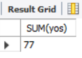
3. ﻿﻿﻿Calculate the sum of salaries and the average age of employees who hold "Programmer" title.
SELECT SUM(salary), AVG(age)
FROM employee_data
WHERE title = 'Programmer';
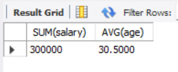
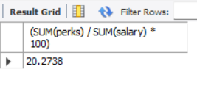
4. ﻿﻿﻿What do you understand from the following statement? select (SUM (perks) /SUM(salary) * 100) from employee_data;
SELECT (SUM(perks) / SUM(salary) * 100)
FROM employee_data;

